Elisa Pibiri
via tirana 16
Selargius 09047 (CA)
N.AR 1565327
CF PBRLSE85B68B354G

Date 31/03/2018

Received the sum of €___35,55_________ from Krumbo Marketing Ltd (C83141) being __articolista__________________________.

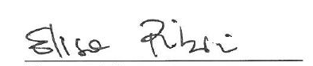

Name and Surname

